First Name | Patrick | Family Name |  | Gane
Organisation | Aalto University/Omya International AG
Address | Baslerstrasse 42, CH-4665 Oftringen, Switzerland
 |  | E-mail | patrick.gane@omya.com
Tel | +41 62 789 2422
 | 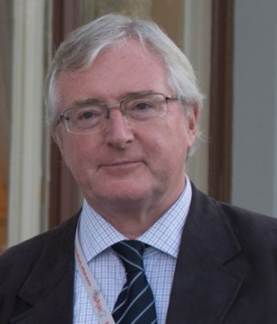
Research direction | Active in a wide range of research fields including crystal structure, with specialisation in the structure and physical properties of antibiotic materials (as Research Assistant, University of Plymouth, 1976-1979), liquid crystals (as Research Fellow at the University of Exeter, 1979-1981), mineral applications in paper and paper coating paints, coatings and adhesives, and functionalised fillers in plastics (as Head of Paper Coating Research, English China Clays, UK, 1981-1994 and continuing in his current position at Omya International AG, Switzerland, 1995 -).  Recent research focus areas include the interaction of liquids and heat with complex porous network media, including nano scale phenomena applied to printing, environmental sciences and composite biomaterials.
Resumé | Born in 1953 and schooled in England, is Professor of Printing Technology at the School of Chemical Engineering, Aalto University, Helsinki, Finland (2006 -), and Vice President Special Projects at Omya International AG, Switzerland (1995 -). He graduated in Physics in 1976 from Imperial College, London, and gained his doctorate from the University of Plymouth in 1979, and granted a postdoctoral Research Fellowship at the University of Exeter.  1994 saw him co-establish the print test equipment company, SeGan Ltd., further developing the Ink Surface Interaction Tester (ISIT), recognized as a research tool in leading laboratories worldwide. He remained as a Company Director until 2007.  He is credited with more than 230 scientific publications and is a named inventor on over 200 corporate patents.  His first Tappi Award was received in 1997 from the Tappi Printing and Graphic Arts Division (Technical Award), and he was elected Tappi Fellow in 2013. He is a two-times winner of the Swedish Kempe Prize, awarded for his corporate and university research groups’ work, respectively, on the development of high speed inkjet print media. He contributes widely to peer reviews for scientific journals, has been and is a member of the scientific committees of selected journals and conferences, and is currently technical programme chair on the Board of iarigai.

